Self Organizing Maps: AHS Programs

Goal: To find the relation between programs and industries and help focus job development for programs to their related industries.

Industries Used

|  |
| --- |
| 6216 Home Health Care Services |
| 6232 Residential Developmental Handicap, Mental Health and Substance Abuse Facilities |
| 6213 Offices of Other Health Practitioners |
| 5417 Scientific Research and Development Services |
| 6221 General Medical and Surgical Hospitals |
| 5419 Other Professional, Scientific and Technical Services |
| 6222 Psychiatric and Substance Abuse Hospitals |
| 6214 Out Patient Care Centres |
| 6231 Nursing Care Facilities |
| 6215 Medical and Diagnostic Laboratories |
| 4461 Health and Personal Care Stores |
| 3345 Navigational, Measuring, Medical and Control Instruments Manufacturing |
| 6239 Other Residential Care Facilities |
| 6223 Specialty (except Psychiatric and Substance Abuse) Hospitals |
| 6233 Community Care Facilities for the Elderly |
| 6219 Other Ambulatory Health Care Services |
| 6243 Vocational Rehabilitation Services |

AHS Co-op Programs

|  |
| --- |
| HLTHHC - Health Studies |
| KINHC - Kinesiology |
| RECHC - Recreation and Leisure |
| RECTHERHC - Recreation and Leisure – Therapeutic Recreation option |
| RECSPBUSHC - Recreation and Leisure – Recreation and Sport Business option |
| PUBHLTHHC - Public Health |
| HLTHPROMHC - Health Studies – Health Promotion option |

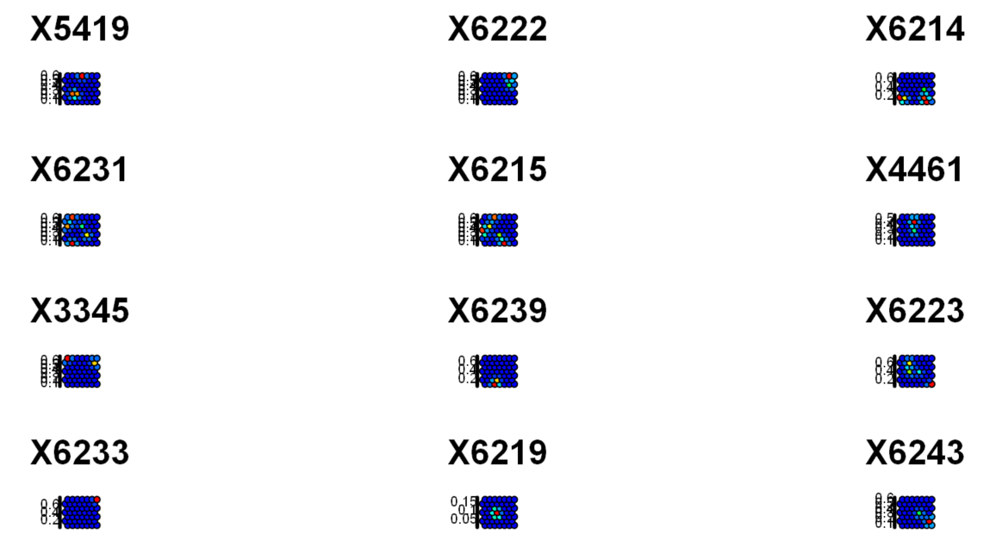Full Self Organizing Map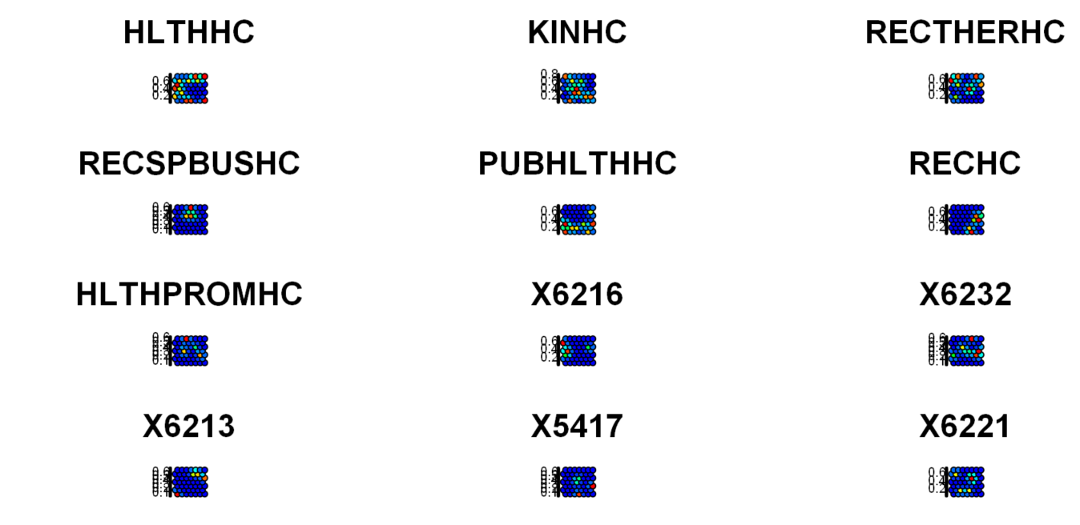

An better analysis is done by grouping the graphs based on the location of their cluster. For example, two graphs that have cluster in the top quadrant of the graph are grouped together. After grouping them based off quadrants, another SOM algorithm is conducted to increase the quality of prediction of the algorithm.

Legend

|  |  |
| --- | --- |
| Strong Correlation |  |
| Medium Correlation |  |
| Weak Correlation |  |

The lines represent the strength of the correlation between each industry and program. The correlations are based off proximity and overlapping of clusters.

Top Quadrant



Bottom Quadrant

Left Quadrant



Right Quadrant

